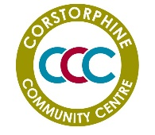
CORSTORPHINE COMMUNITY CENTRE
5 Kirk Loan
Corstorphine
Edinburgh EH12 7HD
Corstorphine Community Centre is a registered SCIO Charity Number SC046009
Application for CCC membership
Name
Address

Email address
Telephone number
Class of membership (tick box) | Adult 18 & over residing in area  Age 15 – 17 residing in area  Non-voting associate member  (i.e. not resident in the area – see map)
List any CCC groups you currently attend

Signature and date

*MAP – NB area is as outlined below
